Title of Workshop Session in English

Diana Mesquita¹, Rui M. Lima², Valquíria Villas-Boas³

¹ Universidade Católica Portuguesa, Faculty of Education and Psychology, Research Centre for Human Development, Porto, Portugal
² ALGORITMI Centre, Department of Production and Systems, School of Engineering, University of Minho, Guimarães, Portugal
³ Federal University of Rio Grande do Sul, Brazil

Email: dmesquita@ucp.pt, rml@dps.uminho.pt, vvillasboas@gmail.com

Abstract
This document should be used as a template for the workshops or hands-on sessions proposed to PAEE/ALE’2025. It provides the intended general structure, format, and other relevant information. Please read the template contents carefully and follow the instructions. Copy your text into this template to preserve the styles and other formatting elements. This type of session should be proposed in English. The abstract should not exceed 300 words, followed by two to four keywords. The workshop proposals are expected to be three pages in length.
Keywords: Active Learning; Engineering Education; Conference Information; Project Approaches.

Introduction
The International Conference in Active Learning in Engineering Education joins the International Symposium on Project Approaches in Engineering Education (PAEE'2025) and the Active Learning in Engineering Education Workshop (ALE'2025). The PAEE/ALE’2025 will occur at the Universidade Católica Portuguesa – Porto, Portugal (Figure 1). More information can be found at the conference website: https://paeeale.dps.uminho.pt/. This document is to be used as a template for submitting proposals for workshop sessions.

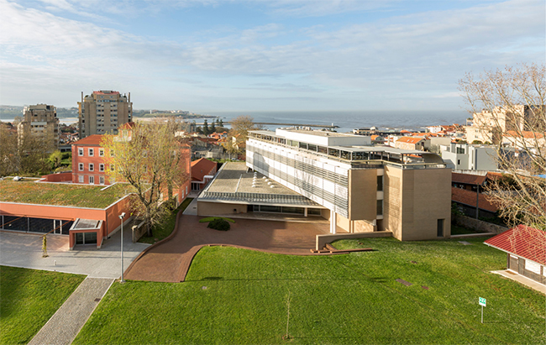
Figure 1. Image of the campus of Universidade Católica Portuguesa, Porto, Portugal

In the first section, the authors are expected to explain the motivations for this workshop or hands-on session, the main expected results and what it is based on. Have you experimented active learning methods at your institution? Have you carried out an innovative research project? Have you developed new models or theories? Explain your workshop or hands-on session and where it comes from. It would be great if you can relate it directly to one of the Conference themes:
- Active Learning and PBL Approaches
- Artificial Intelligence and digital technologies
- Attracting young people to Engineering
- Curriculum design
- Student Assessment
- Inclusion, diversity and ethics in Engineering Education
- Education for sustainability
- Research on PBL and Active Learning
- Student’s engagement and partnership
- Teacher’s Professional Development for Active Learning
- University-Business Cooperation
- Innovative experiences in engineering education

Activities
This type of submission is expected to have sections that indicate the activities the participants will be involved in. The event aims at very active involvement in workshops or hands-on sessions and would like to provide the participants with a short preview of what they can expect from this session. Additionally, this type of submission could describe the resources used during the session and the organization planned for the participants.
Provide information on important concepts that are sustained with relevant literature. Some examples of workshops given in PAEE_ALE past conferences are Dinis-Carvalho & Fernandes (2018), Filho & Lima (2018), Sousa & Alves (2018), Alves (2019), Mesquita (2019), and Villas-Boas (2019). References should use the format shown below.

Expected results
This submission should clearly state what the participants will achieve and/or deliver at the end of the workshop. This is not necessarily a concrete product but could also be the outcomes of a discussion.

Instructions for Authors
Workshop proposals submitted to the event must be in accordance with this document, which should be used as a template by the authors. These submissions are required to have a maximum of three pages, by the following general rules:
- Document file must be in Microsoft Word format applying the styles used in this template.
- Page layout in A4 size with one column text format.
- Entire document written using “Segoe UI” text font.
- Left and right margins of 2 cm; top and bottom margins of 2.5 cm.
- Word style “Normal”: Body text with “Segoe UI” text font size 10, single line spacing, justified, spacing after paragraph 6 pts.
- Word style “Head_Title”: Title using “Segoe UI” text font, bold, size 16, left aligned.
- Word style “Authors”: Author information with “Segoe UI Light” text font, bold, size 10, left aligned.
- Word styles “affiliation” and “email”: Affiliation and email addresses with “Segoe UI” text font, size 8, left aligned.
- Word style “Heading 1”: First level section titles with “Segoe UI” text font, bold, size 14, distance before paragraph of 24 pts and hanging indent of 0.76 pts.
- Word style “Heading 2”: Second level section titles with “Segoe UI” text font, bold, size 12, distance before paragraph of 10 pts and hanging indent of 1.02 pts.
- Word style “Heading 3”: Third level section titles with “Segoe UI” text font, bold, size 10, distance before paragraph of 10 pts and hanging indent of 1.27 pts.
- Don’t use section titles of level 4 and more.
- Do not use footnotes.
- Figure and table captions with “Segoe UI” text font, size 9. Figures and Tables are left aligned.
- References use APA style:
  - Cross reference has “author (year)” or (author, year).
  - Reference list sorted by last name.
Please format your document according to the standards above, including Word styles. To comply with the standards, copy your text into this template.

References
Alves, A. C. (2019). Competencies driven by Lean Education: System-thinking, sustainability and ethics. International Conference on Active Learning in Engineering Education (PAEE_ALE2019), 9, 710–713.
Dinis-Carvalho, J. & Fernandes, S. (2018). How to apply SCRUM in PBL teams. International Conference on Active Learning in Engineering Education (PAEE_ALE2018), 45–46.
Filho, J. C. R., & Lima, R. M. (2018). Agile project management approach for engineering education: eduScrumTM workshop. International Conference on Active Learning in Engineering Education (PAEE_ALE2018), 29–31.
Mesquita, D. (2019). What I hope students will remember from my course in ten years? International Conference on Active Learning in Engineering Education (PAEE_ALE2019), 708–709.
Sousa, R. M., & Alves, A. C. (2018). Hands-on training on reduction of setup times (SMED). International Conference on Active Learning in Engineering Education (PAEE_ALE2018), 8, 26–28.
Villas-Boas, V. (2019). The “Empty Square” Activity. International Conference on Active Learning in Engineering Education (PAEE_ALE2019), 717–718.

